**MongoDB -Aggregation Exercises**

**Shivam Kumar Gupta**

**Atlanta Population**

1. **use db.zipcodes.find() to filter results to only the results where city is ATLANTA and state is GA.**

1. **use db.zipcodes.aggregate with $match to do the same as above.**

1. **use $group to count the number of zip codes in Atlanta.**

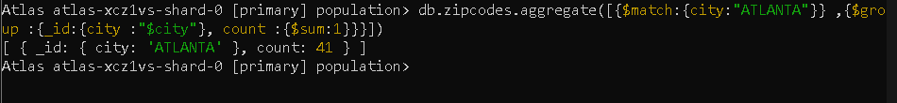

**4. use $group to find the total population in Atlanta.**



**Populations By State**

1. **use aggregate to calculate the total population for each state**

1. **sort the results by population, highest first**

1. **limit the results to just the first 3 results. What are the top 3 states in population?**

**Populations by City**

1. **use aggregate to calculate the total population for each city (you have to use city/state combination). You can use a combination for the _id of the $group: { city: '$city', state: '$state' }**

1. **sort the results by population, highest first**

**3. limit the results to just the first 3 results. What are the top 3 cities in population?**

1. **What are the top 3 cities in population in Texas?**

**Bonus**

**1. Write a query to get the average city population for each state.**

**2. What are the top 3 states in terms of average city population?**

